Angular Reactive Form Exercise

Prerequisite

1. Angular version 9 or above
2. Nodejs version 12.x or above

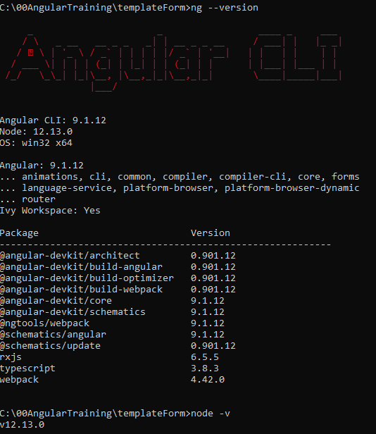

Preparation

1. Create New Angular Project
   1. ng new <project name>



* 1. ng serve

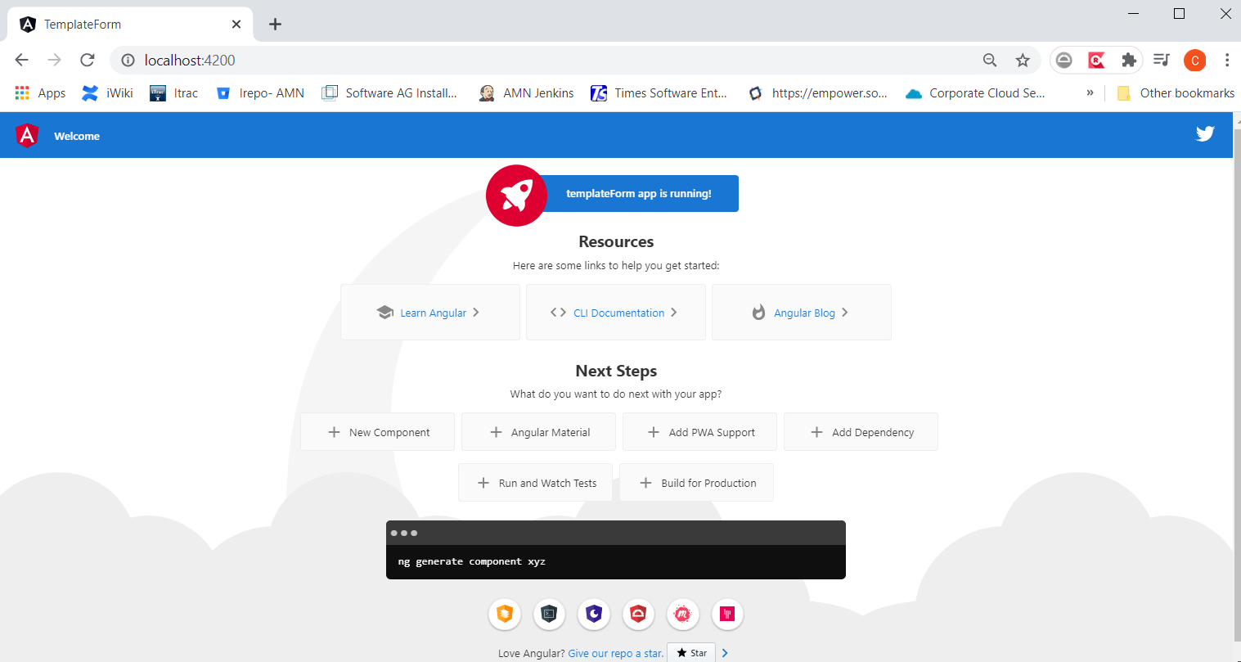

1. Add Bootstrap – add below into ./src/styles.css

@import url('https://unpkg.com/bootstrap@3.3.7/dist/css/bootstrap.min.css');

.btn {

  margin-left: 10px;

}

label {

  display: block;

  padding-top: 5px;

}

Exercise

1. Import ReactiveFormsModule into app.module.ts

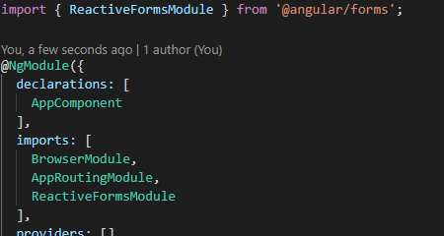

1. Add below into styles.scss(or .css)

.btn {

  margin-left: 10px;

}

label {

  display: block;

  padding-top: 5px;

}

1. Replace app.component.html with below

<h1>EmployeeForm</h1>

<div class="form-group">

  <h2>Personal Information</h2>

  <label>

    Name:

    <input type="text" placeholder="required" />

  </label>

</div>

<div class="form-group">

  <label>

    Phone Number:

    <input type="text" placeholder="required" />

  </label>

</div>

<div class="form-group">

  <label>State:</label>

  <select>

    <option Value="" hidden></option>

    <option *ngFor="let loc of locations" [value]="loc">{{ loc }}</option>

  </select>

</div>

<div class="form-group">

  <h2>Certication if any:</h2>

  <div>

    <label

      >JAVA

      <input type="checkbox" />

    </label>

    <label

      >ANGULAR

      <input type="checkbox" />

    </label>

    <label

      >DOt NET

      <input type="checkbox" />

    </label>

  </div>

</div>

<div class="form-group">

  <h2>Working Experience(s)</h2>

  <div>

    <label>

      Position:

      <input type="text" placeholder="optional" />

      <button class="btn" type="button" id="remove_workExp">X</button>

    </label>

  </div>

  <button class="btn" type="button">Add Another Working Experience</button>

</div>

<button class="btn" id="apply_button">Apply</button>

Note: Test your application with “ng serve” and you should able to get below

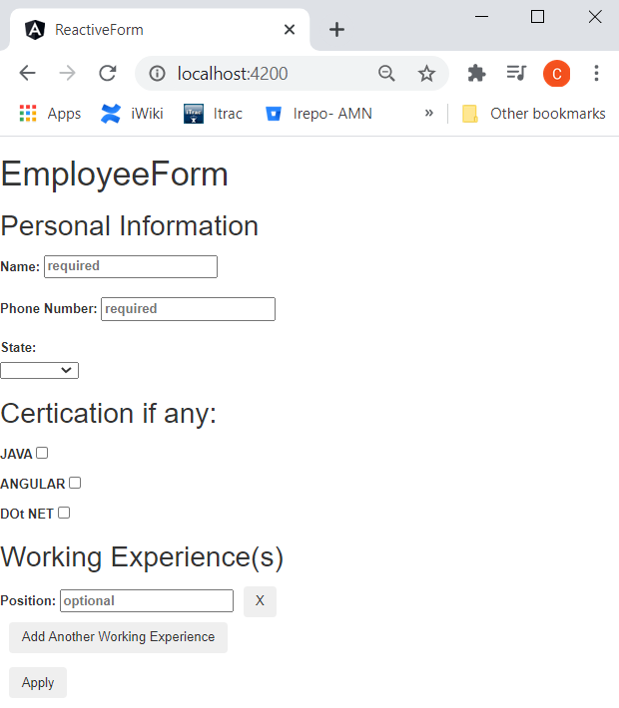

1. Update app.component.ts was below

export class AppComponent implements OnInit {

  locations: string[] = ['Selangor', 'Pahang', 'KL', 'Penang'];

  empForm: FormGroup;

  constructor() {}

  ngOnInit(): void {

  }

1. Inject FormBuilder as below

constructor(private fb: FormBuilder) {}

1. Initialize empForm in ngOnInit() using FormBuilder

ngOnInit(): void {

    this.empForm = this.fb.group({

      name: 'Name here',

      phoneNumber: '',

      state: '',

      cert: this.fb.group({

        java: false,

        angular: false,

        dotnet: false,

      }),

      workExp: this.fb.array([this.fb.control('')]),

    });

  }

1. Add a getter for workExp to allow ngFor to loop it in the template and access it

  get workExp(): FormArray {

    return this.empForm.get('workExp') as FormArray;

  }

1. Add a onSubmit function for form submit

  onSubmit() {

    console.log('this.empForm', this.empForm);

  }

1. Add “add Work Experience” and “remove Work Experience” function

  addWorkExp() {

    this.workExp.push(this.fb.control(''));

  }

  removeWorkExp(index: number) {

    this.workExp.removeAt(index);

  }

1. Add selectState function for update state combo-box value changed

  selectState(event) {

    this.empForm.patchValue({

      state: event.target.value,

    });

  }

1. Update app.component.html with formControlName, formGroup, formArray and functions.

Please note the highlighted.

<h1>EmployeeForm</h1>

<form [formGroup]="empForm" (ngSubmit)="onSubmit()">

  <div class="form-group">

    <h2>Personal Information</h2>

    <label>

      Name:

      <input type="text" formControlName="name" placeholder="required" />

    </label>

  </div>

  <div class="form-group">

    <label>

      Phone Number:

      <input type="text" formControlName="phoneNumber" placeholder="required" />

    </label>

  </div>

  <div class="form-group">

    <label>State:</label>

    <select formControlName="state" (change)="selectState($event)">

      <option Value="" hidden></option>

      <option *ngFor="let loc of locations" [value]="loc">{{ loc }}</option>

    </select>

  </div>

  <div formGroupName="cert" class="form-group">

    <h2>Certication if any:</h2>

    <div>

      <label

        >JAVA

        <input type="checkbox" formControlName="java" />

      </label>

      <label

        >ANGULAR

        <input type="checkbox" formControlName="angular" />

      </label>

      <label

        >DOt NET

        <input type="checkbox" formControlName="dotnet" />

      </label>

    </div>

  </div>

  <div class="form-group">

    <h2>Working Experience(s)</h2>

    <div

      formArrayName="workExp"

      *ngFor="let work of workExp.controls; let i = index"

    >

      <label>

        Position:

        <input type="text" placeholder="optional" [formControlName]="i" />

        <button

          class="btn"

          type="button"

          id="remove_workExp"

          (click)="removeWorkExp(i)"

        >

          X

        </button>

      </label>

    </div>

    <button class="btn" type="button" (click)="addWorkExp()">

      Add Another Working Experience

    </button>

  </div>

  <button class="btn" id="apply_button">Apply</button>

</form>

Additional Exercise

Try remove FormBuilder injection, and use “new FormGroup”, “new FormControl” and “new FormArray” for form initialization.